**Problem :** [**https://leetcode.com/problems/number-of-operations-to-make-network-connected/**](https://leetcode.com/problems/number-of-operations-to-make-network-connected/)

**Approach :**

1. Make an UNDIRECTED graph with the given edges.
2. Now no. edges needed to connect to connect the graph is equal to

**No. of connected components-1**

1. No. of connected components can be found easily by doing a **depth first traversal.**
2. But we also need to find out if we have enough Extra Edges available to connect the components.
3. **No. of Extra Edges = No. Of cycles in all components.**
4. **(imp) To find number of cycles, we need to treat a graph as DIRECTED GRAPH,means follow the procedure of finding number of cycles in Undirected Graphs.**

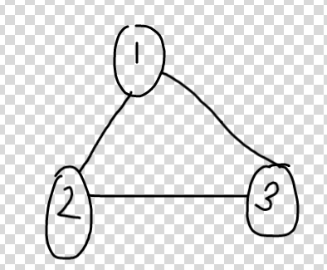

-> So we need to maintain a visited array + samePath array.

-> We detect a Cycle only if the node we are going is **ALREADY VISITED+ON THE SAME PATH.**

-> E.g : dfs visits 1, then 2, then 3, then 1 , CYCLE DETECTED as 1 is on the same path. Now dfs(3) completes as all its neighbors are visited so samePath[3]=false, dfs(2) completes samePath[2]=false,now from 1 dfs again tries to go to 3,and it’s seen as visited , but we can’t say that it’s another Cycle,as 3 is now not on the same path.

-> So number of cycles detected = 1, which means there is 1 extra edge.

**Code :** [**https://leetcode.com/problems/number-of-operations-to-make-network-connected/submissions/**](https://leetcode.com/problems/number-of-operations-to-make-network-connected/submissions/)